15.63: a) 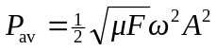
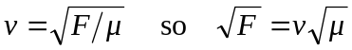
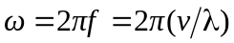

Using these two expressions to replace 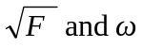 gives
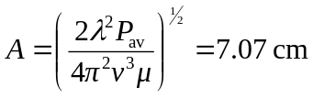
b)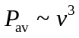 so doubling 